Camerata Sonora

presents

With Common Heart and Voice
Traditional Sacred Music of Scotland,
England, and the United States

Robert Lopez-Hanshaw and Emily Lyons, Directors

Nicolàs Anzaldúa
Sarah Bollt
Alan Brundage
Joan Brundage
Suzanne Cookman
Gita Gnanadesikan
Alisha Nichols
Kate Riley
Ari Slater
Abbie Sorg

The Protestant Reformation’s introduction of congregational singing as an integral part of worship enormously influenced Western music. Out of the Calvinist movement came metrical psalms: vernacular translations of the psalms from the Bible in metrical verse set to interchangeable tunes. The musical styles represented in this program evolved separately from this tradition. Despite their differences in character, there is in all of these styles a compelling earnestness that the experience of communal singing makes palpable. We therefore invite you not only to listen, but also to join in singing at points during the performance. Following the directive of 18th-century Methodist theologian John Wesley, we encourage you to “sing lustily and with good courage.”

Although the musical traditions represented in this program are unambiguously Christian, our diverse group of singers embraces the unifying spirit of this music that transcends religion, which is why we borrow a phrase from the Scottish Metrical Psalter and call this program With Common Heart and Voice.

Scottish Metrical Psalms
Harmony and English text from the Scottish Metrical Psalter (1635)
Scots-Gaelic text from Fuinn na Salm: Gaelic Psalmody, collected by L. MacBean (1900)

“Martyrs”
“London”

Martyrs
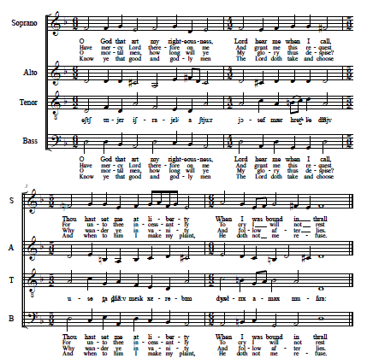

English West Gallery
The texts of these West Gallery songs are all from New Version of the Psalms of David
by Nahum Tate and Nicholas Brady (1696)

“Mt. Ephraim” -------------------------------------Benjamin Milgrove (1731-1810)
“Canterbury” ---------------------------------------------Thomas Clark (1775-1859)
“Fairfield” -------------------------------------Joseph Stephenson (ca. 1723-1810)
“Chatham” ---------------------------------------------John Barwick (1741-ca.1800)
“Tabernacle” -----------------------------------------------James Leach (1762-1798)

––––––––Intermission––––––––

American Sacred Harp

“Complainer” -----------------------------------text and music by William Walker (1835)
“Immensity”---------------------by Eliakim Doolittle (1806), text by Isaac Watts (1719)
“Africa” ----------------------------by William Billings (1770), text by Isaac Watts (1709)
“Stratfield” --------------------------------by Ezra Goff (1786) text by Isaac Watts (1719)
“Return Again” ----------arr. William L. Williams (1850), text by John Newton (1779)
“New Britain” -------from Columbian Harmony (1829), text by John Newton (1779)

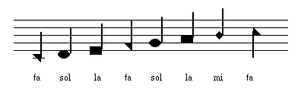

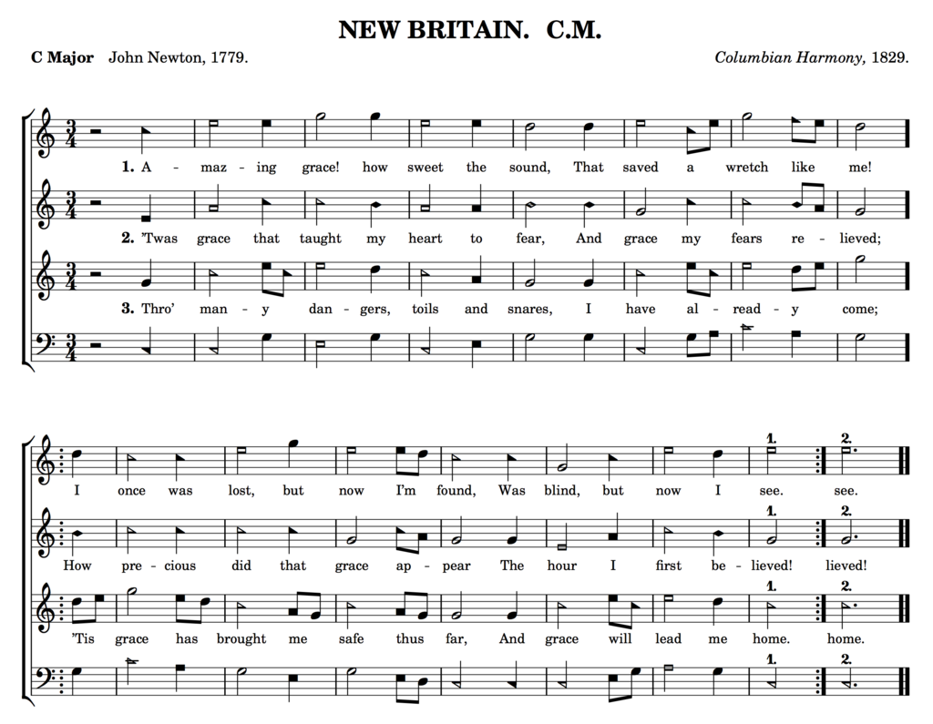

Variations on “London New”

“Newtoun” --------------------------------------------from Scottish Metrical Psalter (1635)
“New London” -------------------------------------from Fuinn na Salm: Gaelic Psalmody
“London New” ----------------from Playford’s Psalms (1671), text by Tate and Brady
“My Rising Sun” -------------arr. C.H. Gilliland (1960), text by William Cowper (1774)

“Poor Wayfaring Stranger”
Traditional Appalachian

I am a poor wayfaring stranger
While journ’ying through this world of woe
Yet there’s no sickness, toil, nor danger
In that bright land to which I go

I’m going there to see my father
I’m going there no more to roam
I’m only going over Jordan
I’m only going over home

I know dark clouds will gather o’er me
I know my way is rough and steep
Yet beauteous fields lie just before me
Where God’s redeemed their vigils’ keep

I’m going there to see my mother
She said she’d meet me when I come
I’m only going over Jordan
I’m only going over home

––––––––––––––––––––Thank You–––––––––––––––––––

John Consedine
for your generous financial support
Muriel Fisher
for coaching us on the Scots-Gaelic text
Hugh Foley
for your insights into hymn lining traditions in America
Members of Tucson Fasola
for introducing us to Sacred Harp singing

